Historical Setting for Daniel 10-12
605 B.C. – Babylonians in power. Nebuchadnezzar takes Jewish people from Jerusalem and makes them captive in Babylon.
539 B.C. – Persians gain power. The Jews are promised they can return and rebuild Jerusalem / Temple.
331 B.C. – Greeks gain power. Alexander the Great emerges as a strong conqueror but dies early at age 32
- Alexander’s empire is divided among 4 generals
  - Ptolemy
  - Seleucus
  - Philip
  - Antigonus
- The Ptolemy (Egypt) and Seleucid (Syria) empires emerge as dominant forces.
- Constant fighting between the Seleucids in the North and Ptolemy’s in the South while Israel is sandwiched in between.
- 175 B.C. Antiochus IV emerges as a Seleucid king and does much harm to the Jewish people in Jerusalem.
  - Kills many Jews
  - Desecrates the Temple
  - Ends sacrifices
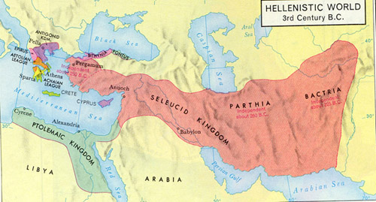

Historical Setting for Daniel 10-12
605 B.C. – Babylonians in power. Nebuchadnezzar takes Jewish people from Jerusalem and makes them captive in Babylon.
539 B.C. – Persians gain power. The Jews are promised they can return and rebuild Jerusalem / Temple.
331 B.C. – Greeks gain power. Alexander the Great emerges as a strong conqueror but dies early at age 32
- Alexander’s empire is divided among 4 generals
  - Ptolemy
  - Seleucus
  - Philip
  - Antigonus
- The Ptolemy (Egypt) and Seleucid (Syria) empires emerge as
dominant forces.
- Constant fighting between the Seleucids in the North and
Ptolemy’s in the South while Israel is sandwiched in between.
- 175 B.C. Antiochus IV emerges as a Seleucid king and does
much harm to the Jewish people in Jerusalem.
  - Kills many Jews
  - Desecrates the Temple
  - Ends sacrifices

